
Applied Science Private University
Faculty of Information Technology

Graduation Project (1) Report

Medical Center

Prepared by:
Deema Fadi Nafea 202020129
Mahmoud Nabil Abuobeed 202011151
Malik Foaud Alnabulsieh 201911152

Supervised by:
Hadeel Ahmad

January 2024

Copyright © 2023-2024 Applied Science Private University. All rights are reserved
Contents
Abstract ii
Chapter 1: Introduction 1
1.1 Description of the current situation and opportunity 1
1.2 Related work 1
1.3 Problem statement (limitation of current systems) 4
1.4 Problem solution 4
1.5 Project objectives 5
1.6 Technology and tools used. 5
1.7 Project plan for GP2 (Gantt chart, PERT chart) 6
Chapter 2: Requirements and Analysis 8
2.1 Software Process Model 8
2.2 System scope with explanation 9
2.3 List of Functional Requirements and Non-Functional Requirements 10
2.4 Use Case Diagram with Use Cases descriptions. 14
Chapter 3: Design 23
3.1 Conceptual Class Diagram 23
3.2 Provisional Database ER Diagram 24
References 25
Appendix 26

Abstract
The goal of our project is to treat people in the easiest ways possible when they become ill and are unable to reach health care centers. Emphasizing the need for telehealth services, the project aims to enable patients to effectively manage their health conditions remotely. It identifies significant limitations in current health care systems, such as the inability to physically access care, long wait times for appointments, unnecessary clinic visits, urgent cases requiring immediate attention, and frequent patient inquiries. The proposed solution involves a multi-faceted approach, including clinic, home, online and urgent appointments, comprehensive medical records management, and user-rated physician profiles to ensure reliability, easy access to healthcare, medication reminders, and improved patient-physician communication. The project objectives are brief: enhance the reliability of the application through user ratings, simplify patients' access to healthcare, ensure medication adherence through reminders, create detailed medical records for accurate health descriptions, promote effective communication channels, and promote the concept of telehealth based on Successful precedents. Overall, this initiative seeks to revolutionize healthcare access and management by offering diverse appointment options, robust medical records, and effective communication, addressing critical limitations in the current healthcare landscape.

Chapter 1: Introduction
In contemporary society, a prevalent challenge confronted by numerous individuals is the difficulty in accessing medical clinics, particularly during periods of illness. Recognizing this widespread issue, our project aims to address the impediment through the development of a comprehensive application. This innovative solution encompasses various features to assist patients effectively. Among the key functionalities are online appointment booking with healthcare professionals, home visits , urgent care and streamlined appointment scheduling. By amalgamating these diverse elements within a single application, we strive to provide a holistic and user-friendly platform that caters to the diverse needs of individuals seeking medical assistance. Through the seamless integration of technology, our proposal endeavors to enhance the accessibility and convenience of healthcare services for a broad spectrum of users.

Description of the current situation and opportunity
Numerous individuals encounter challenges accessing healthcare facilities when unwell, highlighting the essential need for a remote healthcare service. This service aims to assist patients in managing their health conditions effectively.

Related work


Tebcan is a healthcare platform offering online access to medical services and appointments. It connects patients with a wide range of healthcare providers. Users can book appointments, consult with doctors virtually, and manage their health records. Tebcan aims to streamline healthcare access and improve patient-doctor interactions through its digital platform. It operates in multiple countries, providing a convenient way for people to seek medical assistance. [1]

Easy Doc is a medical software designed to manage clinic operations and patient records. It offers features like appointment scheduling, electronic health records (EHR), billing, and inventory management for healthcare facilities. Easy Doc aims to streamline administrative tasks, enhance patient care, and improve the efficiency of medical practices. It's utilized by clinics and healthcare providers to optimize their operations and provide better services to patients[2].

Zocdoc is an online healthcare appointment booking platform that enables patients to find and schedule appointments with healthcare providers in their area. Zocdoc streamlines the healthcare appointment booking process for patients and providers alike [3].

Practo is Healthcare platform connecting doctors & patients virtually. Practo offers a web-based platform which benefits both patients and doctors. Practo search enables patients to browse through doctor profiles online and book confirmed appointments[4].


HealthTap is a telehealth app that revolutionizes primary care by providing ongoing, affordable care with a dedicated, online primary care doctor you love. With or without insurance, HealthTap is your go-to solution for personalized medical care that saves you time and money. Find the best online doctors with HealthTap and schedule your doctor appointment same-day or same-week [5].

The following table shows the difference between our application and similar applications:
Applications | Clinic appointment | Home appointment | Online appointment | Urgent appointment | Medical record
Tebcan | yes | yes | yes | no | yes
Easy Doc | yes | yes | yes | yes | yes
Zocdoc | yes | no | yes | no | yes
Practo | yes | no | yes | no | yes
Healthtap | yes | yes | yes | yes | yes
My app | yes | yes | yes | yes | yes

Apps | Multi-language support | Ratings and reviews | Additional amount  for  doctor's  visit | Payment feature | Push notifications
Tebcan | yes | yes | no | yes | yes
Easy Doc | yes | yes | no | yes | no
Zocdoc | yes | yes | no | yes | yes
Practo | yes | yes | no | yes | yes
Healthtap | no | yes | yes | yes | yes
My app | yes | yes | yes | yes | yes

Problem statement (limitation of current systems)
1- The patient is unable to go to health care and Some diseases cannot be diagnosed by online meeting
2- The patient is unable to wait for a long time to book an appointment with the doctor
3- Some diseases do not require going to the clinic
4- Some critical cases cannot wait to be treated
5- The patient suffers from some recurring questions.

Problem solution
In this project, we wanted to help all groups of people monitor their health and healthy lifestyle. We have provided a place for people to visit their doctors, and in the event that they are unable to visit the doctor due to their busyness, we have provided them with home visits by doctors, and if they want to inquire about some information, this feature is available in Our project, and if an emergency happens to them, our project is prepared to handle emergency situations, and medical records are also available to help the doctor and patient understand his condition correctly.

Project objectives
1- Make the application more reliable by placing ratings for doctors by the user
2- Helping the patient to access health care with the least effort and in the fastest time
3- A reminder to take medications at the correct times
4- Providing a medical record that describes the patient’s condition
5-Providing an effective communication service between the patient and the doctor
6- Developing the concept of remote health care by adopting precedent.

Technology and tools used.
- Flutter
Is a multi-platform, open-source, and free framework for creating mobile applications, is just a smart application development package or SDK, specifically used for developing user interface or UI programming education Dart for back-end programming, the most important things were focused on when developing Flutter, as you want to look at
- Microsoft Office 365
Microsoft 365 brings together premium Office apps like Word, Excel, and PowerPoint and, allows us to access documents and edit files from anywhere.

- Draw.io: draw.io is an technology stack for building diagramming applications, and the world’s most widely used browser-based end-user diagramming software.
-Google chrome.

Project plan for GP2 (Gantt chart, PERT chart)
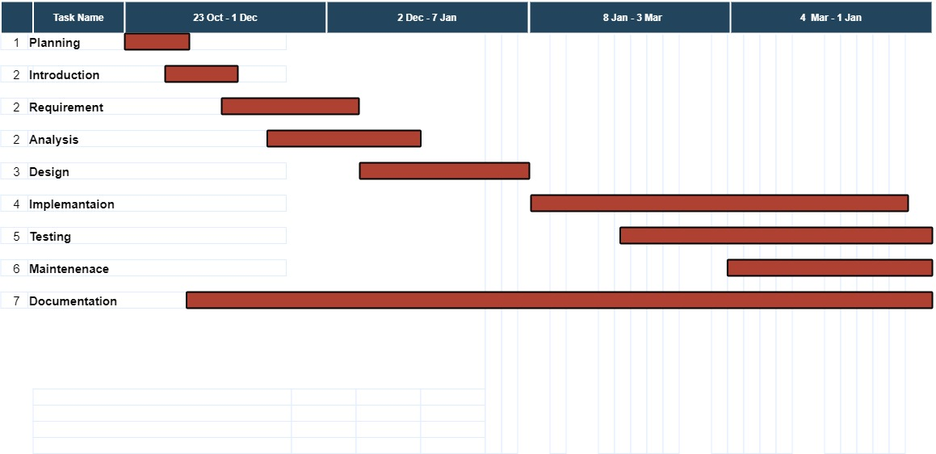

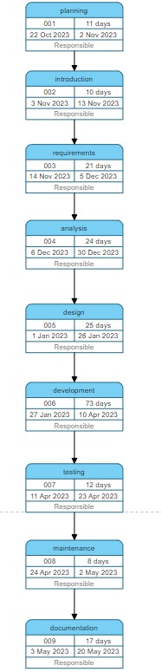

Chapter 2: Requirements and Analysis

Software Process Model
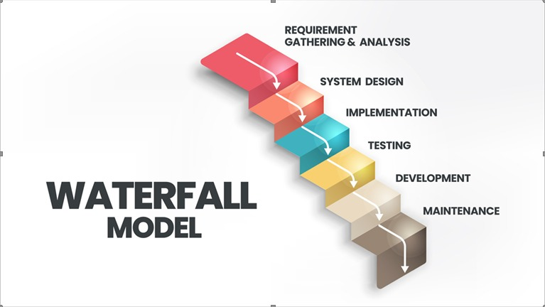
The Waterfall model is a traditional and linear approach to software development where each phase must be completed before the next one begins. Here are some scenarios in which the Waterfall model might be suitable:
1. Clear and Stable Requirements:
• If the project requirements are well-defined, stable, and unlikely to change significantly during the development process, the Waterfall model can be effective. This is because changes in requirements after the project has started can be challenging to accommodate in the Waterfall model.
2. Small to Medium-sized Projects:
• The Waterfall model is often suitable for small to medium-sized projects with limited complexity. It's easier to manage and control the entire project when it is not overly large or complicated.
3. Client Requires a Full Specification Upfront:
• In situations where the client or stakeholders require a detailed project plan and documentation before development begins, the Waterfall model can be beneficial. It provides a comprehensive project plan from the outset.
4. Well-understood Technology:
• If the technology and tools to be used in the project are well-understood and stable, there may be less risk of encountering unexpected challenges during the development process.
5. Regulatory Compliance Requirements:
• Projects that must adhere to strict regulatory compliance standards often benefit from the Waterfall model. The linear and documented nature of the model can help in meeting regulatory requirements.
6. Limited Resources and Budget:
• Projects with limited resources and a fixed budget may find the Waterfall model suitable because it provides a clear structure, making it easier to estimate costs and allocate resources.
7. Low Customer Involvement During Development:
• If the client or stakeholders prefer a hands-off approach during the development process and are comfortable waiting until the end to see the final product, the Waterfall model aligns with this level of customer involvement.

System scope with explanation
The system aims to develop a comprehensive healthcare application that addresses challenges in accessing medical clinics, focusing on goals such as enhancing reliability through the physician classification system, providing effortless access to healthcare, implementing a medication reminder feature, maintaining detailed medical records, and enabling communication. Effective, and contributes to remote health care. Project deliverables include an easy-to-use mobile app, user rating system, online appointment booking, home visiting services, urgent care provisions, streamlined appointment scheduling, medication reminders, secure medical records management, and an effective communications platform. Key functions include user registration, appointment booking, home visit requests, urgent care handling, medication reminders, access to medical records, and communication tools. Tasks include system design, front-end/back-end development, database administration, feature integration, testing, and user training, with a deadline of January 7, 2024, and no associated costs.

List of Functional Requirements and Non-Functional Requirements
Functional Requirements:
1. User Registration:
1.1 The Users shall be able to create accounts.
1.2 The user profile shall be created with details.
2. Appointment Booking:
2.1 The Users shall be able to schedule appointments with healthcare professionals.
2.2 The system shall be display available time slots for each healthcare professional.
2.3The system shall be Confirmation notifications for booked appointments.
3. Online Consultation:
3.1 The system shall be able to Implement a video or chat system for online consultations.
3.2 The system shall be Support file uploads for sharing relevant documents or images during consultations.
4. Home Visits:
4.1 The system shall be allow users to request home visits by healthcare professionals.
4.2 The system shall be Provide a schedule and confirm home visits.
5. Urgent Care:
5.1 The system shall provide information and advice on how to deal with Urgent Care
6. Appointment Reminders:
6.1 The system shall be Send timely reminders for upcoming appointments.
7. Medical Records:
7.1 The system shall be maintain electronic health records for each user.
7.2 The system shall be Enable doctors to update and access patient medical record.
8. Communication Platform:
8.1 The system shall be allow users to ask questions, seek advice, and receive responses.
8.2 The system shall be Provide messaging between patients and doctors.
9. Rating System:
9.1 The system shall be provide assessment for healthcare professionals.
9.1.1 The system shall allow the user to evaluate through comments.
9.1.2 The system shall allow the user to evaluate through stars.

10.Emergency Services:
10.1 The system shall be Include quick access to emergency contact information.
11. common questions Section:
11.1 The system shall be Provide a section to address recurring questions.
11.2 The system shall be provided questions that cover a range of common health concerns
12.User Feedback:
12.1 The system shall be Collect feedback from users about their experiences.
12.2 The system shall be Use feedback to improve the application.
Non-Functional Requirements:
1. Security:
1.1 The system shall be Ensure secure data transmission and storage.
1.2 The system shall be Implement user authentication and authorization protocols.
2. Scalability:
2.1 The system shall be design the application to handle the growing user base.
2.2 The system infrastructure shall be scalable to support increased usage.
3. Performance:
3.1 The system shall be Ensure the application responds promptly to user actions.
3.2 The system shall be Optimize load times for different functionalities.
4. Reliability:
4.1 The system shall be Minimize downtime and ensure the application is available when needed.
4.2 The system shall be Implement backup and recovery mechanisms for user data.
5. Usability:
5.1 The system shall be Create an intuitive and user-friendly interface.
5.2 The system shall be Ensure ease of navigation for users of varying technological proficiency.
6. Compatibility:
6.1 The system shall be Ensure the application is compatible with various devices and operating systems.

7. Compliance:
7.1 The system shall be Comply with healthcare data protection regulations and standards.
7.2 The system shall be Adhere to relevant privacy laws and guidelines.
8. Availability:
8.1 The system shall be Ensure 24/7 availability of critical features.
8.2 The system shall be Schedule maintenance during low-usage periods.
9. Interoperability:
9.1 The system shall be Integrate the application with existing healthcare systems if applicable.
9.2 The system shall be Support interoperability with third-party health devices or applications.
10.Data Backup:
10.1 The system shall be Regularly back up user data to prevent loss in case of system failures.
10.2 The system shall be Implement a robust data backup and recovery strategy.
11.Monitoring and Analytics:
11.1 The system shall be Implement monitoring tools to track application performance.
11.2The system shall be Use analytics to gain insights into user behavior and system usage.
12.Regulatory Compliance:
12.1 The system shall be Ensure compliance with healthcare industry regulations and standards.
12.2 The system shall be Regularly updating the system to meet changing regulatory requirements.

Use Case Diagram with Use Cases descriptions.
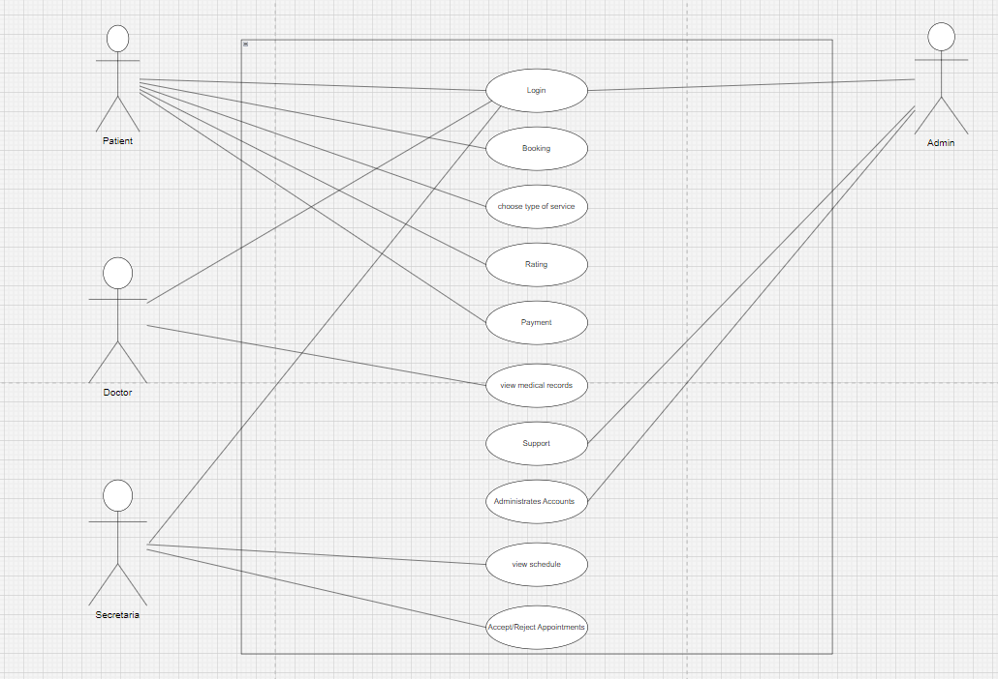

Use Case Name: | Login
ID: | 1
Actor: | Patient, Doctor, Admin
Description: | Allows registered users (patients, doctors, admins) to log in to the application
Pre-conditions: | User must be registered in the system.
Post-conditions: | User gains access to their respective dashboard and feature
Normal-Flow: | -User opens the application.  -User selects the 'Login' option.  -User enters their username and password.  -System validates the username and password.  -If the username and password are correct, user gains access to the application.
Alteration-Flow: | If the entered username and password are incorrect, the system prompts the user to re-enter the correct details.
Exception: | System experiences technical issues preventing users from logging in.

Use Case Name: | Booking
ID: | 2
Actor: | Patient
Description: | Allows patients to schedule appointments with healthcare professionals.
Pre-conditions: | User must be logged in and have selected a healthcare provider.
Post-conditions: | Appointment is scheduled and confirmed.
Normal-Flow: | -Patient selects a healthcare provider.  -Patient checks the provider's availability.  -Patient selects an available time slot.  -System prompts patient to confirm the appointment.  -Patient confirms, and the appointment is scheduled.
Alteration-Flow: | If the selected time slot is unavailable, system prompts the patient to choose another slot.
Exception: | Technical issues prevent the appointment from being scheduled.

Use Case Name: | Rating
ID: | 3
Actor: | Patient
Description: | Allows patients to rate and provide feedback for healthcare provider after appointments.
Pre-conditions: | Patient must have completed an appointment.
Post-conditions: | Rating and feedback are submitted and visible for everyone
Normal-Flow: | -Patient accesses the completed appointment.  -Patient selects the option to provide a rating and feedback.  -Patient rates and writes feedback.  -System records and displays the rating and feedback for the healthcare provider.
Alteration-Flow: | If patient decides not to provide feedback, the system doesn't prompt further action.
Exception: | System encounters an error in recording the provided rating and feedback.

Use Case Name: | View Medical Record
ID: | 4
Actor: | Patient, Doctor
Description: | Allows patients and doctors to view the medical records of the patient.
Pre-conditions: | User must be logged in.
Post-conditions: | User accesses the medical record.
Normal-Flow: | -User navigates to the medical records section.  -User selects the specific medical record.  -System displays the medical record information.
Alteration-Flow: | If the medical record is not found, system prompts the user to check their access rights or the record’s availability.
Exception: | Technical issues prevent the system from displaying the medical record.
Use Case Name: | Choose Type of Service
ID: | 5
Actor: | Patient
Description: | Allows patients to select the type of service they require, such as in-clinic appointment, telemedicine, home visits, etc.
Pre-conditions: | User must be logged in.
Post-conditions: | Service type is selected for further actions.
Normal-Flow: | -Patient accesses the service selection feature.  -Patient views available service options (in-clinic, telemedicine, home visits, etc.).  -Patient selects the desired service type.  -System confirms the selection and proceeds accordingly.
Alteration-Flow: | If the selected service is unavailable or not supported, the system provides alternative options or information on limitations.
Exception: | Technical issues prevent the patient from selecting the service type.

Use Case Name: |  | View Schedule
ID: |  | 6
Actor: |  | Patient, Doctor
Description: |  | Allows patients and doctors to view their scheduled appointments and availability.
Pre-conditions: |  | User must be logged in.
Post-conditions: |  | User accesses their schedule.
Normal-Flow: |  | -User navigates to the schedule section.  -User selects their schedule or calendar.  -System displays the scheduled appointments or availability.
Alteration-Flow: |  | If there are no scheduled appointments, the system prompts the user with a message indicating the absence of appointments.
Exception: |  | Technical issues prevent the system from displaying the schedule.
Use Case Name: | Payment
ID: | 7
Actor: | Patient
Description: | Allows patients to make payments for services rendered through the application.
Pre-conditions: | User must be logged in and have selected a payable service.
Post-conditions: | Payment for services is processed.
Normal-Flow: | -Patient selects a service that requires payment.  -System calculates the cost and displays it to the patient.  -Patient selects a payment method (credit card, mobile payment, etc.).  -Patient enters payment details and confirms the transaction.  -System processes the payment and provides a confirmation message.
Alteration-Flow: | If payment fails, the system prompts the patient to re-enter payment details or try an alternative payment method.
Exception: | Technical issues prevent the payment from being processed.

Use Case Name: | Support
ID: | 8
Actor: | Patient, Doctor, Admin
Description: | Allows users (patients, doctors, admins) to access support for inquiries, technical issues, or assistance.
Pre-conditions: | User must be logged in.
Post-conditions: | User receives assistance or resolution to their query.
Normal-Flow: | -User navigates to the support section or contacts support directly.  -User describes their issue or inquiry.  -System registers the request and assigns it to an available support representative.  -Support representative addresses the query or issue.  -User receives assistance or resolution.
Alteration-Flow: | If the support team is unavailable, the system notifies the user of potential delays and provides alternative contact methods or instructions.
Exception: | Technical issues prevent the support request from being registered or addressed.

Use Case Name: | Administrates Accounts
ID: | 9
Actor: | Admin
Description: | Allows the admin to manage user accounts, permissions, and settings within the system
Pre-conditions: | Admin must be logged in.
Post-conditions: | Changes to user accounts or settings are successfully applied in the system.
Normal-Flow: | -Admin accesses the account administration section within the system.  -Admin views a list of user accounts and their associated permissions.  -Admin performs actions such as creating, modifying, or deleting user accounts and adjusting permissions and settings.
Alteration-Flow: | If there are account-related issues or conflicts detected, the system alerts the admin and offers options to resolve them.
Exception: | Technical issues prevent the system from executing account-related actions accurately or entirely.

Use Case Name: | Accept/Reject Appointments
ID: | 10
Actor: | Doctor
Description: | Allows doctors to accept or reject appointment requests from patients.
Pre-conditions: | Doctor must be logged in and have pending appointment requests.
Post-conditions: | Appointment request is either accepted or rejected.
Normal-Flow: | -Doctor accesses the pending appointments section.  -Doctor views the pending appointment requests.  -Doctor reviews the details and selects to accept or reject the appointment.  -System updates the status of the appointment request based on the doctor’s decision.
Alteration-Flow: | If the doctor needs more information or clarification, the system provides options to communicate with the patient or request additional details.
Exception: | Technical issues prevent the doctor from updating the appointment status.

Chapter 3: Design

Conceptual Class Diagram

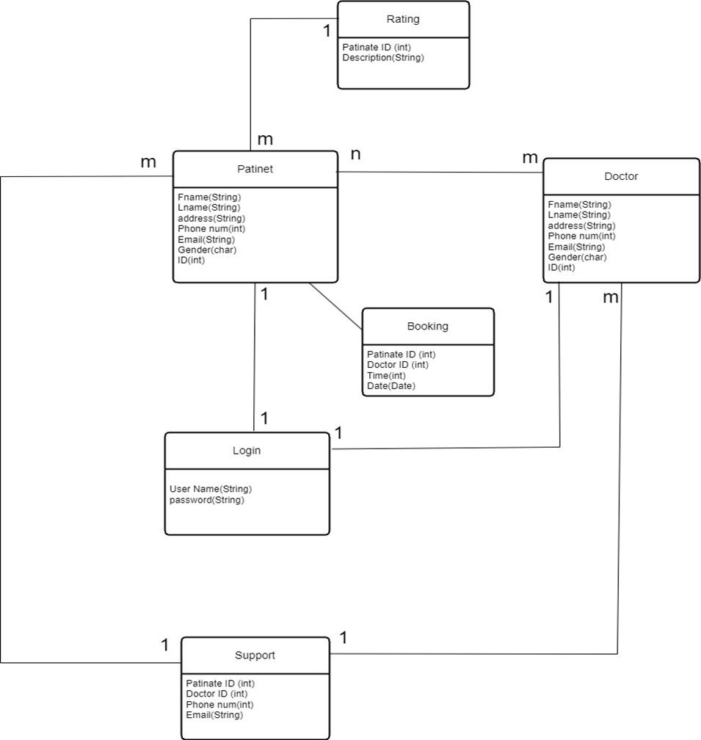

Provisional Database ER Diagram
Because our project uses non-relational data, we do not need to draw an ERD

References
[1]-www.tebcan.com
[2]-www. easydoc.sa/ar/
[3]- www.zocdoc.com
[4]- www.practo.com
[5]-www. Healthtap.com

Appendix
Any additional information or data that supports or extends the main document or report.

